Executive Summary
This report outlines the architecture and feature set for a full-featured freelancer marketplace (à la Upwork/Fiverr) spanning IT and non-IT services. We analyze target users (clients, freelancers, admins) and core workflows, comparing top competitors (Upwork, Fiverr, Freelancer.com, Guru) in a feature table. Key platform features include user profiles/portfolios, advanced search/filters, project posting with proposals/bids, escrow-based payments, messaging (chat/video), contracts/milestones, reviews, and dispute resolution【76†L175-L183】【34†L500-L504】. We recommend robust authentication (OAuth/SSO, 2FA, RBAC) and a normalized SQL schema with tables for users, projects, proposals, contracts, milestones, payments, reviews, messages, etc. A Mermaid ER diagram and sequence charts (user signup, project lifecycle, escrow) illustrate data relationships and flows. We outline sample RESTful APIs with JWT/OAuth auth, an MVP feature backlog with phased releases, a security/testing checklist, and estimated costs/timelines. Throughout, we cite industry best practices (e.g. OWASP Top 10【51†L26-L34】) and official sources (Upwork support, GDPR guides) to ensure a rigorous design.

Target Users and Roles
The platform has three primary user types: Freelancers (independent service providers), Clients (individuals or businesses posting projects), and Administrators (internal staff managing the system). Freelancer accounts must allow building a public profile/portfolio with skills and past work; clients can post jobs and hire freelancers. (For example, Upwork enforces separate “Client” vs “Freelancer” accounts: only client accounts can post jobs and hire talent【44†L46-L49】.) Each role has distinct interfaces: freelancers see project listings and their proposals/earnings, while clients see their open projects, received bids, and payment status. Admins manage categories, moderate content, and access analytics. All users authenticate (e.g. email/password or SSO), with role-based access controlling permissions (clients cannot edit other clients’ jobs, freelancers cannot create job postings, etc.). We recommend supporting account verification (ID checks, skills tests) to enhance trust and a clear onboarding flow for each role.

Competitor Feature Comparison
The table below compares key features of leading freelance marketplaces. All major platforms include profiles, search, and payment protection, but differ in business model and workflows. We cite official sources where available (Upwork support and industry analyses【36†L37-L41】【34†L500-L504】).
Feature | Upwork | Fiverr | Freelancer.com | Guru.com
Service Model | Project-based & hourly contracts【36†L37-L41】 | “Gig” packages (fixed-price services) | Project postings + contests【27†L183-L189】 | Project postings (fixed/hourly/recurring)
Job Posting | Clients post jobs with details (free to post)【30†L43-L51】 | No free-form posting; buyers browse listed gigs | Clients post projects or contests (free to post) | Clients post jobs/projects
Bidding/Proposals | Yes – freelancers submit proposals to posted jobs | No – buyers order gigs directly from listings | Yes – freelancers bid on jobs (and contests) | Yes – freelancers send quotes/offers to posted jobs
Contests | No (Upwork does not use contests) | No | Yes – design, coding contests where freelancers submit entries | No
Direct/Hire Now | Yes – clients can “Direct Hire” or invite to interview | Yes – purchase gig for instant engagement | Yes – clients can award directly (Buy Now) | Yes – clients can hire freelancers/companies directly
Payment Protection (Escrow) | Yes – “project funds” (escrow) held until milestone approved【36†L37-L41】 | Yes – Fiverr holds payment in escrow until delivery approved【34†L500-L504】 | Yes – milestone/escrow payments (Escrow.com integration) | Yes – SafePay escrow holds funds until client approves work【13†L56-L60】
Time Tracking | Yes – Upwork Desktop tracks time for hourly jobs | No (services are fixed-price) | Yes – Freelancer Desktop App with screenshots【25†L183-L191】 | Yes – hourly contracts tracked via Workrooms (time logs)
Contracts & Milestones | Yes – create fixed-price milestones, track hourly work | No formal milestones; gig pricing tiers | Yes – milestone payment system for projects | Yes – define milestones/deliverables on contracts
Multi-Currency | Yes – support multiple currencies via payment gateways | Yes – supports various currencies at fixed rates | Yes – supports major currencies | Yes – supports common currencies (via payment providers)
Fees/Commissions | Freelancer fee: 5–20% sliding (depends on lifetime earnings)【36†L37-L41】; clients pay no platform fee | Seller fee ~20%, buyer fee ~5% (flat) | Freelancer fee 10% (min $5); client fee 3% (min $3) | Freelancer job fee 5–9% (based on membership tier); employer fee ~2.9%【71†L0-L4】
Profiles & Portfolios | Yes – detailed profiles with portfolios/rating【76†L175-L183】 | Yes – seller profiles with reviews, portfolio samples | Yes – profiles with portfolio, work history, ratings | Yes – profiles with portfolios and company pages
Skills/Categories | Yes – broad categories, skill tags, filters | Yes – categorized gigs by service type | Yes – many categories, skill-based searches | Yes – organized by industry categories and skill tags
Messaging/Communication | Yes – built-in chat/video via Upwork Workroom | Yes – internal messaging after order | Yes – project chat, calls, files in “Workroom” | Yes – integrated messaging and project collaboration in Workroom
Reviews & Ratings | Two-way reviews (freelancer↔client) | Buyer reviews seller; no formal seller reviews of buyers | Two-way ratings | Two-way ratings/reviews (client rates freelancer, vice versa)
Dispute Resolution | Yes – Upwork support will mediate disputes on funded milestones【36†L66-L69】 | Yes – Fiverr dispute center handles order issues【34†L506-L509】 | Yes – dispute process via Milestone Escrow | Yes – SafePay dispute process (support mediates payment disputes)
Mobile App | Yes (iOS, Android) | Yes (iOS, Android) | Yes (iOS, Android) | Yes (iOS, Android apps available)
Additional Features | Agencies support (teams), enterprise solutions, skill tests | Seller levels, Fiverr Pro, subscription plans (Fiverr Business) | Contests, freelance services (Quick tasks), desktop app | Company accounts, hiring for teams, payroll option
All major platforms provide escrow-secured payments and on-platform dispute processes【36†L37-L41】【34†L500-L504】 to ensure trust. Table rows are based on official FAQs and industry reports (e.g. Upwork’s help center and Fiverr’s documentation) and should guide our feature set.

Core Features & Workflow
Drawing on industry best practices, our platform must include:
- User Profiles/Portfolios: Detailed profiles for freelancers and clients, including skills, experience, work history, and a portfolio of past work. Both sides can rate each other (two-way reviews)【76†L175-L183】. This builds trust and helps users make informed decisions. (As one guide notes, portfolios are “the primary conversion”, so they should be first-class【5†L73-L75】.)
- Search and Discovery: Full-text search and faceted filters (by skills, category, price, experience level, location, etc.) to quickly match freelancers and projects【76†L183-L192】. For example, Upwork and Guru offer advanced search with skill and category filters. We should index key fields (title, skills, descriptions) and consider Elasticsearch or Algolia for performance and relevance.
- Job/Service Posting: Clients can post projects (with title, description, budget, deadlines) or browse “gigs”/service packages. Freelancers can also list fixed-price services (“gig” or “catalog”) for direct purchase. Projects support fixed-price or hourly contracts. Upwork lets clients post jobs (free) and review freelancer proposals【30†L43-L51】; Fiverr primarily uses predefined gig listings. Our platform should support both models or at least the project-posting workflow.
- Proposals/Bidding: Freelancers submit proposals or bids to jobs with their price and cover letter【76†L199-L205】. Clients compare proposals on price, ratings, and delivery plans. A transparent bidding system (like Upwork/ Freelancer) helps clients choose the best fit. (Gig-style buying bypasses bidding, offering instant start.)
- Payments & Escrow: An integrated payment system holds funds in escrow after project/milestone funding, releasing them to the freelancer only upon client approval【36†L37-L41】【34†L500-L504】. Support credit cards, PayPal, bank transfers, and other popular gateways (Stripe Connect, etc.) for multi-currency and global reach【15†L209-L213】. Implement milestones so large projects can be broken into parts (paid in stages). Refunding a milestone if work is unsatisfactory should be handled by the escrow system. (For security, Upwork’s “project funds” are held before work begins【36†L37-L41】.)
- Contracts & Milestones: Once a client awards a project, a contract is created linking the project and freelancer. Define milestones with deliverables and deadlines. Support both fixed-price and hourly contracts, with automated billing. (For hourly work, incorporate time-tracking.)
- Time Tracking: For hourly jobs, include a built-in time tracker (like Upwork or Freelancer) so freelancers log hours and clients verify work. The system auto-generates invoices for tracked time【25†L183-L191】. Time logs become part of the contract history.
- Messaging & Collaboration: Built-in chat, video call, and file-sharing tools keep communication on-platform【76†L214-L220】. Centralized messaging (with audit trail) prevents off-platform conversations and enhances security. (Fiverr’s in-app chat and Upwork’s Workroom offer examples.) We should also allow meeting scheduling (calendar integration) and possibly video conferencing (Zoom API or WebRTC).
- Milestone Payments & Invoicing: Tie payments to milestones. When a freelancer submits work, the client reviews; upon approval, the system triggers payment release and generates an invoice/receipt. Support automated invoicing (with tax info) and generate statements for users. For compliance, allow clients/freelancers to enter tax IDs (VAT/GST) so that invoices include required fields【55†L54-L60】【56†L58-L62】.
- Reviews & Ratings: After project completion, both client and freelancer rate each other (1–5 stars) and leave feedback. These reviews feed into user reputation and help future partners assess trust. (A two-way rating system is key for trust【76†L175-L183】.) Display overall rating and review snippets on profiles and in search results.
- Dispute Resolution: Provide an on-platform dispute mechanism【76†L229-L234】. If a client rejects a milestone or refuses payment, a dispute can be filed. Admins or a support team can then mediate, using evidence (work submissions, chat logs, ratings) to resolve issues. As with competitors, this feature should clearly define roles (mediator) and steps for resolution. Escrowed funds should be held until disputes are closed.
- Notifications: Send email/in-app alerts for key events (new message, proposal received, milestone funded/paid, review left, etc.). Real-time notifications (or daily digests) keep users engaged. Use asynchronous queues (e.g. RabbitMQ, AWS SNS) to handle high notification volume.
- Analytics & Reporting: Provide dashboards: freelancers see earnings, completed projects, upcoming milestones; clients see spending, active contracts, proposals status. Admin dashboards track platform metrics (user counts, transactions, disputes, etc.) for monitoring growth and health.
These core features align with industry norms. For example, Yo!Gigs lists eight “essentials” including profiles, search, bidding, escrow, chat, time tracking, and mobile optimization【76†L175-L183】【76†L207-L212】. We should exceed basic offerings by adding robust category taxonomy (multi-level categories/subcategories【66†L159-L167】), skill tagging, and portfolio galleries.

Authentication & Authorization
Secure, flexible authentication is critical. We should support email/password logins with strong password policies (hash+salt, no plaintext) and enforce multi-factor authentication (2FA) (e.g. TOTP or SMS) for account security【53†L1508-L1512】. Consider allowing social login (OAuth) with Google, LinkedIn, etc., to streamline signup. For enterprise clients, we could later add SAML or OpenID Connect SSO integration (like Azure AD/SAML)【38†L60-L68】.
Authorization should be role-based (RBAC)【38†L60-L68】: at minimum, roles are freelancer, client, and admin. Each API/route checks the user’s role: e.g. only clients can POST /projects, only the project’s assigned freelancer can update a contract deliverable. Admins have full access to moderation APIs (manage categories, review flagged content). Use secure session or token-based (JWT) authentication for REST APIs, with short-lived tokens and refresh tokens. Ensure secure storage of secrets (use a secrets manager) and implement session timeout and logout features.
SSO best practices (from industry) emphasize using reputable identity providers, enforcing 2FA, and logging auth events【38†L60-L68】. We will log all login attempts and administrative changes for auditing. Sensitive actions (e.g. changing payment account) require re-authentication or 2FA confirmation.

Database Design (SQL)
We recommend a relational database (PostgreSQL or MySQL) with a normalized schema. Core tables include:
- users (user_id PK, email, password_hash, role ENUM{‘client’,‘freelancer’,‘admin’}, created_at, verified_email, etc.).
- freelancer_profiles (profile_id PK, user_id FK, first_name, last_name, bio, hourly_rate, etc.).
- skills (skill_id PK, name) and a join user_skills (user_id, skill_id).
- categories (category_id PK, name, parent_id FK to categories for subcategories) for taxonomy.
- projects (project_id PK, client_id FK to users, title, description, category_id FK, budget_min, budget_max, status, created_at, etc.).
- gigs (gig_id PK, freelancer_id FK, title, description, price, delivery_time) – optional if supporting gig listings.
- proposals (proposal_id PK, project_id FK, freelancer_id FK, bid_amount, cover_letter, status, submitted_at).
- contracts (contract_id PK, project_id FK, freelancer_id FK, agreed_terms, fixed_price, hourly_rate, status, start_date, end_date).
- milestones (milestone_id PK, contract_id FK, title, amount, due_date, status).
- time_entries (entry_id PK, contract_id FK, freelancer_id FK, start_time, end_time, description) for hourly billing logs.
- payments (payment_id PK, contract_id FK, milestone_id FK NULLABLE, payer_id FK, payee_id FK, amount, currency, payment_method, status, created_at).
- reviews (review_id PK, contract_id FK, from_user_id FK, to_user_id FK, rating, comment, created_at).
- disputes (dispute_id PK, contract_id FK, milestone_id FK NULLABLE, raised_by FK, issue_description, status, created_at).
- messages (message_id PK, sender_id FK, recipient_id FK, contract_id FK NULLABLE, content, sent_at).
- attachments (attachment_id PK, message_id FK NULLABLE, contract_id FK NULLABLE, file_url, filename).
- notifications (notif_id PK, user_id FK, type, content, target_url, is_read, created_at).
- audit_logs (log_id PK, admin_id FK, action, target, details, timestamp).
Primary keys (PK) and foreign keys (FK) enforce referential integrity. For example, projects.client_id → users.user_id, milestones.contract_id → contracts.contract_id, etc. We will index common query fields: e.g. INDEX on projects(category_id), proposals(project_id), messages(recipient_id), and full-text indexes on project/freelancer titles and descriptions for search.
Transactions must wrap multi-step flows (e.g. creating a contract and funding escrow). Audit logging: record critical events (deletions, disputes) in audit_logs with user/timestamp.
Multi-tenancy: If later offering this as a SaaS for multiple organizations, include a tenant_id FK on tables or separate schemas. But for a single marketplace, ensure each user’s data remains isolated (clients only see their own projects).
Backup/Restore & Migration: Employ regular backups (e.g. nightly snapshots) and point-in-time recovery for the database. Use a schema migration tool (Flyway/Liquibase or ORM migrations) to version and apply schema changes. Keep development, staging, and production databases synchronized via migrations and seeding scripts.

ER Diagram
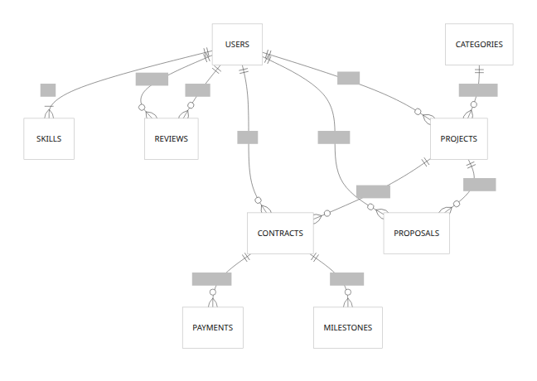
This ER diagram (Mermaid syntax) highlights key relationships: a user posts projects and writes proposals; a project may receive many proposals; a contract links one project with a hired freelancer; contracts have milestones and payments; users write/receive reviews. Many-to-many between users and skills is denoted by {}. This corresponds to the tables listed above.

Sequence Flows
User Signup Flow:
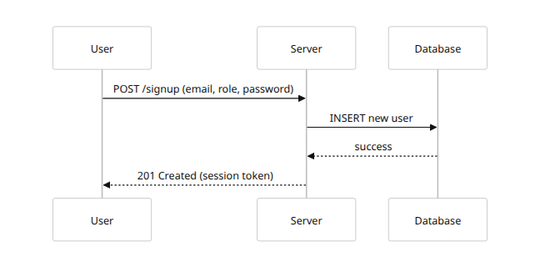
This flow shows a new user (client or freelancer) submitting signup data; the server creates the user record and returns success with authentication token. (Further flows would include email verification.)
Project Lifecycle (Client-Posting / Freelancer-Bidding):
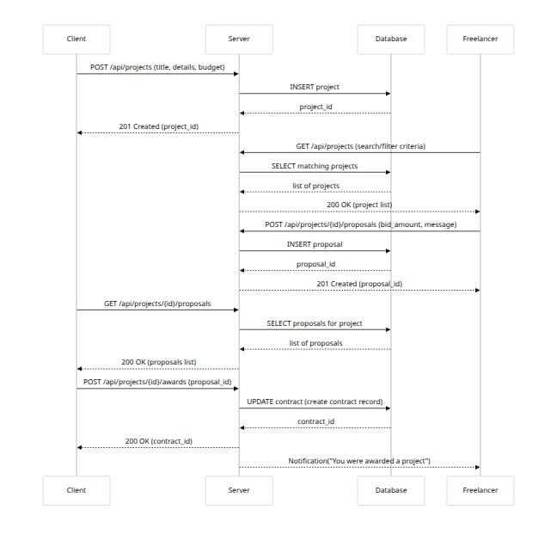
This sequence illustrates a client posting a project, freelancers retrieving and bidding, the client reviewing bids, and awarding a contract. After awarding, a contract is created in the database, and the freelancer is notified.
Payment/Escrow Flow:
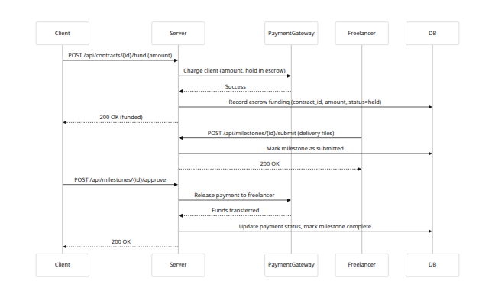
Here, the client funds a milestone by creating an escrow payment. The freelancer submits work, the client approves, and the escrow is released. If the client disputes before approval, an alternative dispute path would be triggered instead of approval.

Sample API Endpoints & Auth Patterns
We will expose a RESTful JSON API. Key endpoints (examples):
- Auth & Users: POST /api/signup, POST /api/login, GET /api/users/me, PUT /api/users/me (profile update). Public signup/login; other user actions require a Bearer JWT with role.
- Projects: GET /api/projects (public search), POST /api/projects (client-only), GET /api/projects/{id}, PUT /api/projects/{id} (client-only, to update), DELETE /api/projects/{id} (client-only).
- Proposals: POST /api/projects/{id}/proposals (freelancer-only), GET /api/projects/{id}/proposals (client-only), GET /api/proposals/{id}, PUT /api/proposals/{id} (freelancer to update or withdraw).
- Contracts & Milestones: POST /api/projects/{id}/awards (client hires freelancer), GET /api/contracts/{id}, POST /api/contracts/{id}/milestones, PUT /api/milestones/{id}, etc.
- Payments: POST /api/contracts/{id}/fund (client funds milestone), webhook endpoints for payment status, GET /api/payments/{id}.
- Messaging: GET /api/messages/{contract_id}, POST /api/messages/{contract_id} (authenticated, participants only).
- Reviews: POST /api/contracts/{id}/review (freelancer or client after completion), GET /api/users/{id}/reviews.
- Admin APIs: e.g. GET /api/admin/users, PUT /api/admin/categories, protected by admin token (Role=admin).
Auth Patterns: We suggest JWT tokens (or OAuth2). Include user role in the JWT claims for RBAC. Use HTTPS for all API calls. For web clients, store tokens securely (e.g. httpOnly cookies or secure storage). Protect against CSRF on state-changing calls (use CSRF tokens or require custom headers). Limit token lifetime and support token refresh.

Scalability & Performance
To support growth, the platform will scale horizontally. Key strategies:
- Caching: Use Redis or Memcached to cache frequent reads (project listings, category lists, user sessions) and reduce DB load. HTTP responses (e.g. list of categories) can be cached with appropriate TTL.
- Read Replicas: Host database read-replicas for heavy read queries (search results, profile views) while writes go to the primary. This improves read throughput.
- Sharding/Partitioning: Initially, a single DB cluster is fine. If very large (millions of users/projects), partition by geography or user ID range. Sharding can be added later (e.g. separate DB per major region to reduce latency).
- Connection Pooling: Use a pool for DB connections (e.g. PgBouncer) to handle concurrent queries.
- Asynchronous Tasks: Offload heavy tasks (email sending, report generation, search indexing) to background workers (Celery, AWS Lambda) so web requests remain fast.
- Elastic Scaling: Deploy servers in the cloud (AWS/GCP/Azure) behind an auto-scaling group. Use containers (Docker/Kubernetes or ECS) to easily scale stateless app servers. For DB, use a managed RDS with auto-scaling storage.
- CDN: Serve static assets (images, CSS/JS) via a CDN (e.g. CloudFront) to reduce latency worldwide.
We will monitor key metrics (response times, DB load). Before sharding, we will scale up vertically (larger machine) and tune queries/indexes. Only shard once caching and replicas are saturated【49†L168-L176】.

Security & Compliance
Security is paramount. Our platform will follow best practices and compliance standards:
- OWASP Top 10: Mitigate common web risks (SQL injection, XSS, CSRF, broken auth, etc.). For example, use parameterized queries, sanitize user input, set secure HTTP headers (Content-Security-Policy, X-Frame-Options), and enforce HTTPS everywhere. Regularly review OWASP Top 10 guidelines as a checklist【51†L26-L34】.
- Data Encryption: Use TLS 1.3 for all data in transit (HTTPS). Encrypt sensitive data at rest (database and file storage encryption via KMS). Do not store full payment card data (use tokenization via PCI-compliant gateways). Encrypt user passwords with a strong hash (bcrypt/scrypt/Argon2).
- PCI-DSS (Payments): If handling credit card payments, ensure PCI compliance: use secure payment APIs (Stripe, PayPal) so our servers never see raw card numbers, implement required logging and encrypt log files, and undergo PCI audits if needed.
- GDPR & Data Privacy: Comply with GDPR (and India’s DPDP Act) for personal data. This includes obtaining explicit consent for data collection, providing “right to be forgotten” (ability for user to delete account and data), data portability (export data on request), and privacy notices. Minimize data collection (only ask for needed info)【53†L1467-L1475】. For example, do not collect unnecessary personal details, and regularly purge data no longer needed【53†L1468-L1475】. If handling EU/Indian users, allow them to set preferences and consent to cookies. If a data breach occurs, notify authorities within 72 hours as required by GDPR.
- Authentication Security: Enforce strong passwords and 2FA【53†L1508-L1512】. Implement account lockouts after repeated failed logins. Store password reset tokens securely (one-time use, expire quickly). Use CAPTCHA or rate-limiting on login/signup to deter bots.
- Auditing & Monitoring: Log all security-relevant events (logins, failed logins, password changes, admin actions). Use monitoring tools (e.g. Sentry, Datadog) to detect anomalies or attacks. Perform regular security scans (SAST/DAST).
- Compliance: In India, GST (Goods & Services Tax) and TDS rules apply: the platform must collect 18% GST on fees from Indian users unless they supply a valid GSTIN【56†L58-L62】【56†L94-L98】. Similarly, EU VAT rules require collecting VAT on service fees from EU clients (unless they provide VAT ID)【55†L54-L60】. We should build tax fields into invoices and payment flows, or integrate with tax-compliance APIs.
Security Checklist (examples): Ensure input validation on all fields; secure cookie flags (HttpOnly, Secure); Content-Security Policy to prevent XSS; MFA for admin roles; least-privilege DB roles; regular penetration testing. Use tools like OWASP ZAP for automated scanning.

Payments & Escrow
We will integrate reputable payment gateways (e.g. Stripe Connect, PayPal for Marketplaces, or Razorpay/CCAvenue in India) to handle transactions. Key points:
- Escrow Flow: The platform acts as intermediary. When a client awards a job, they fund the agreed amount into escrow (via the gateway). Only when milestones are approved do we release funds to the freelancer【36†L37-L41】【34†L500-L504】. This protects both parties. The system must handle refunds (if client cancels) and disputes (see above).
- Gateways & Currencies: Support multiple payment methods and currencies. Stripe Connect, for instance, can split payments: take a platform fee and pay out to the freelancer. The platform fee (commission) can be charged either to the freelancer or client, per our business model (Upwork charges freelancers, others charge buyers/sellers differently). The image below illustrates example logos of multiple gateways: 【70†embed_image】 This shows that we must support major credit cards (Visa, MasterCard), PayPal, and popular local options (e.g. UPI, bank transfers). Multi-currency support means storing a currency code on transactions and possibly converting/displaying balances in local currency.
- Fees & Billing: Implement logic to deduct the platform commission automatically on each payment. For example, Upwork uses a sliding scale (e.g. 20% down to 10%)【36†L37-L41】, while others use flat rates. These fees should be calculated server-side and included in invoices. Provide users with transaction history and downloadable invoices (with tax breakdowns if applicable).
- Refunds: If a dispute or cancellation occurs, we must handle partial or full refunds. The system should trigger a refund through the gateway and update payment records. Keep an audit trail of refunds.

Search & Discovery
For effective matching, implement a robust search engine:
- Full-Text Search: Index project titles/descriptions and freelancer profiles/skills. Use a dedicated search service (Elasticsearch or Algolia) for fast, relevance-ranked queries across large data. Provide keyword search plus filtering (by skill tags, categories, price range, location).
- Faceted Filters: In search results, allow filtering by category, skill, price, rating, delivery time, etc. This improves discovery. For example, filter by “hourly rate ≤ $20” or “location = India”.
- Recommendations: Use simple ML or heuristic recommendations (“Related projects” or “Recommended freelancers” based on past hires). This can be enhanced over time. Logging user behavior (clicks, hires) will enable future collaborative filtering.
We should also cache popular search results (e.g. “featured freelancers”) to handle load spikes.

UI/UX Design Patterns
The interface should be clean, intuitive, and mobile-responsive (per [76†L236-L241]). Key patterns:
- Main Landing Page: Feature a prominent search bar (“Find the best professionals…”) and showcase categories or featured freelancers to entice new users. For inspiration, a Yo!Gigs sample UI shows a clean search-focused dashboard【68†embed_image】.
- Onboarding Flows: After signup, guide freelancers to complete their profile (skills, portfolio) and clients to post their first project. Use progress indicators. Collect only necessary info at each step to avoid form fatigue.
- Freelancer Dashboard: Once logged in, freelancers should see a dashboard summarizing “Your Active Proposals”, “Upcoming Milestones”, “Messages”, and earnings graph. Provide quick links to edit profile or view contracts.
- Client Dashboard: Clients see “Your Posted Projects”, “New Proposals”, and “Invoices”. They should easily click to review proposals or fund milestones. Include shortcuts to post a new project or top-up wallet.
- Project Pages: Clear layout: project title, budget/timeline, detailed description, and a list of proposals. Allow clients to highlight certain skills or questions. Freelancers should see similar layout when browsing or bidding.
- Responsive Design: Use a mobile-first layout or responsive CSS framework (Bootstrap, Material UI, etc.). Ensure all pages (search results, chat, dashboards) work well on phone/tablet. Consider native mobile apps after web MVP if demand is high.
Throughout, maintain consistent branding, legible fonts, and intuitive icons. Trust signals (verification badges, secure payment icons) should be visible to reassure users.

Integrations
To enhance functionality, integrate with third-party services:
- Email/SMS: Use a transactional email service (SendGrid, Mailgun) for notifications (signup, proposals, payments) and an SMS gateway (Twilio) for phone verification and alerts. This ensures reliable delivery.
- Calendar: Allow users to add milestones/deadlines to Google/Outlook Calendar. Integrate Google Calendar API so that clients/freelancers can schedule calls or reminders.
- Video Calls: Integrate a video conferencing API (Zoom, Twilio Video, or Jitsi) for project meetings. Provide an “Start Call” button in each contract room.
- Rich Code/Text Editing: For developer services, offer an embedded code editor (e.g. CodeSandbox, GitHub Gist embed) or rich text editor in messaging for code snippets. For design, allow Figma file embeds or previews.
- File Storage: Use cloud storage (AWS S3 or similar) for user-uploaded files (portfolios, submitted work). Generate time-limited URLs for secure access.
- Payment & Tax: As noted, integrate Stripe/PayPal; optionally integrate a tax API (like Avalara) to calculate VAT/GST for invoices.
- Analytics: Integrate Google Analytics and/or Mixpanel to track user behavior and conversion.
- Monitoring: Use Sentry or Datadog for error monitoring in frontend and backend.
These integrations accelerate development and leverage proven infrastructure rather than building everything in-house.

Testing & CI/CD
A rigorous testing regime and automated deployment is essential:
- Automated Testing: Write unit tests for all business logic (e.g. proposal acceptance, payment releases) and integration tests for API endpoints. Use a testing framework (e.g. Jest for JS/TS, pytest for Python). Implement end-to-end (E2E) tests simulating user flows (signup → post project → bid → hire) with a tool like Cypress or Selenium.
- Security Testing: Regularly run vulnerability scanners (e.g. OWASP ZAP) against deployed builds. Include static code analysis (ESLint, CodeQL) and dependencies checks (Snyk).
- Load/Performance Testing: Before major releases, conduct load tests on critical endpoints (search, posting, messaging) to identify bottlenecks. Tools like JMeter or k6 can simulate traffic.
- Continuous Integration (CI): Use a CI pipeline (GitHub Actions, GitLab CI, Jenkins) to run tests on every commit/pull request. Merge only if tests pass.
- Continuous Deployment (CD): Automate deployments to staging for QA, and to production after approvals. Use blue-green or rolling deploys to minimize downtime. Infrastructure-as-code (Terraform or CloudFormation) should version control cloud resources.
- Code Reviews & QA: Enforce peer code reviews for all merges. Maintain a QA environment for manual testing of UIs and new features. Maintain a regression test suite.

Deployment Architecture
We recommend a cloud-native deployment:
- Cloud Provider: AWS/GCP/Azure. (No specific tech stack mandated, but e.g. Node.js/React or Python/Django with PostgreSQL).
- Containers: Package services as Docker containers. Use Kubernetes (EKS/GKE) or a managed container service. This supports easy horizontal scaling.
- Load Balancing: Use a cloud load balancer (AWS ALB/ELB) to distribute web traffic across app servers. Terminate SSL at the LB.
- Database: Use a managed SQL service (e.g. Amazon RDS) for automated backups and multi-AZ failover. For scaling reads, use RDS read replicas.
- Cache & Queue: Host Redis (Elasticache) for caching and RabbitMQ/SQS for background job queues.
- CDN & Storage: Host static assets and uploads on S3 behind a CDN (CloudFront).
- Network & Security: Use VPC with private subnets for databases. Security groups and WAF to limit traffic.
- Infrastructure as Code: Define all resources in Terraform/CloudFormation to allow reproducible environments.
This cloud architecture ensures high availability (multi-AZ), easy scaling, and resilience.

Monitoring & Logging
Implement comprehensive monitoring:
- Metrics: Use CloudWatch/Stackdriver or Prometheus to track CPU, memory, DB performance, request rates, error rates. Set alerts (e.g. 5xx error spike triggers a pager).
- Logging: Centralize logs (application logs, access logs) to a service like ELK (ElasticSearch-Logstash-Kibana) or Splunk. Correlate logs with user sessions (use request IDs).
- Error Tracking: Use Sentry for uncaught errors in both backend and frontend. Track and triage exceptions.
- Uptime Checks: Monitor uptime with health-check endpoints (e.g. /health), and use an external service (Datadog, Pingdom) to alert on downtime.
Logs should capture authentication events, payments, and admin actions. Retain logs per compliance (e.g. GDPR suggests not storing personal logs longer than necessary).

Feature Backlog & Roadmap
We suggest a phased approach:
- MVP (Phase 1):
- User authentication and profiles (clients & freelancers)【76†L175-L183】
- Project posting and proposal bidding【76†L199-L205】
- Basic search by category/keyword
- Messaging/chat between client and freelancer【76†L214-L220】
- Payment/escrow with at least one gateway (credit card/PayPal)【76†L207-L212】
- Reviews/ratings and dispute resolution workflow【76†L229-L234】
- Simple dashboards (list of projects, proposals, active contracts)
- Mobile-responsive web UI【76†L236-L241】
- Release 2: (next 3–6 months)
- Advanced search filters (skills, budget, etc.)
- Time tracking for hourly contracts【76†L222-L227】
- Multi-currency and tax (VAT/GST) handling in payments【56†L58-L62】【55†L54-L60】
- Notifications (email/SMS) for events
- Freelancer portfolios & enhanced profile fields (skills, experience)
- Invoicing and financial analytics (earnings, spending charts)
- Release 3: (following 6–9 months)
- Mobile native apps (React Native or Flutter) or PWA enhancements
- Video calling integration and calendar scheduling
- Additional payment methods (UPI, local wallets) and payout methods
- Enhanced admin tools (content moderation, reports, user management)
- Security hardening (2FA, audit logs) and scaling improvements
- Release 4+: (long-term/advanced features)
- AI-driven recommendations (match projects to freelancers)
- Multi-language support, region-specific portals
- Enterprise features (SAML SSO for corporate accounts, team management)
- Additional verticals (if expanding beyond general freelancing)
Prioritize MVP tasks first. Use Agile sprints with continuous user testing to refine features.

Security Checklist and Testing Plan
Before launch, ensure the following:
- Authentication/Authorization: Enforce HTTPS, secure cookie flags, input sanitization. Implement 2FA (see [53†L1508-L1512]) and lockout on multiple failed logins.
- Data Protection: All sensitive data encrypted at rest; only store minimal personal data. Comply with GDPR/DPDP by providing user data export/delete. Regularly review data access controls.
- OWASP Top 10: Verify none of the top 10 vulnerabilities are present (e.g. use parameterized queries to prevent SQLi, proper escaping/CSP for XSS)【51†L26-L34】.
- Payment Security: PCI compliance (no raw card data); secure webhook endpoints.
- Error Handling: Do not leak stack traces to users; log them server-side.
Testing Plan:
- Unit and integration tests for all business logic (run on every PR).
- End-to-end tests simulating major flows (sign up, hire, pay, review). Use tools like Cypress to catch regressions.
- Load testing on key endpoints to ensure DB and servers can handle peak load.
- Security testing: Run automated scanners (Snyk, OWASP ZAP) regularly. Consider a third-party penetration test before full launch.
- User acceptance testing with real or proxy clients/freelancers to validate UX.
By rigorously testing and following the above security checklist, we minimize risks.

Cost & Timeline Estimate
For a small dedicated team (e.g. 3–5 developers, 1 designer, 1 QA/PM), an MVP build could take 6–9 months. According to industry benchmarks, MVP development ranges from ~$5k (freelancers) up to ~$150k (in-house high-end) depending on scope【64†L72-L80】. A moderate estimate: $50k–$100k for an MVP with the above features (assuming offshore dev costs). Full feature completion and scaling could push total development to $150k–$250k+ over 12–18 months.
Hosting/cloud costs are modest initially: a single db instance and a few app servers (~$200–$500/month on AWS for a small load), plus services (CDN, cache, email/SMS, monitoring) which might add another ~$100–$200/month. Third-party fees (payment gateways, video API) are mostly per-transaction.
Costs can be reduced by using managed services and open-source tools. Using a ready-made code library for marketplace features (authentication, payments) can also cut dev time.
Summary: A lean MVP could be built in ~6 months for ≈$50k, with full roll-out in ~12–18 months and ~$150k–$200k (all-in)【64†L72-L80】. Ongoing costs include cloud hosting (~$2k/year), support, and marketing.
Sources: Market research and platform docs (Upwork, Yo!Gigs, etc.) inform these estimates【64†L72-L80】【76†L175-L183】.

